Course Number: 420-DA3-AS

Course Title: Multi-tier Applications Development

Session: Autumn 2020

Group Number: 7398

Name: **Danial Gosse**

Project Description:

We are tasked to build a windows form application using three different approaches to database implementation in c#. In this application we are taking form as a bookstore. We must be able to use CRUD on all the tables relevant in creating a system like this.

Database Design:

To view full size please check ERD.PNG



Class Diagram:

To view full size please check EntityDesignerDiagram.BMP

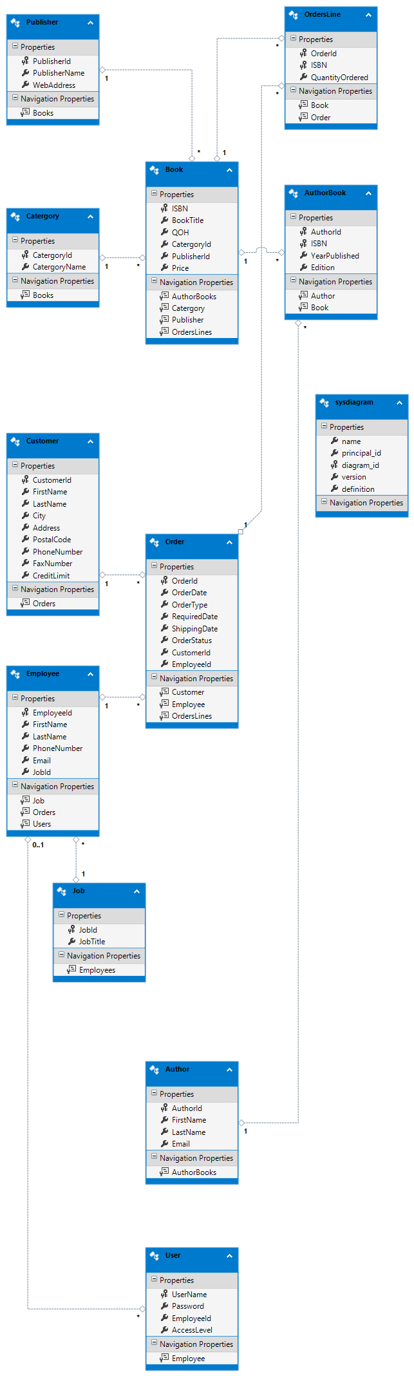

Design of GUI:

**Login:**

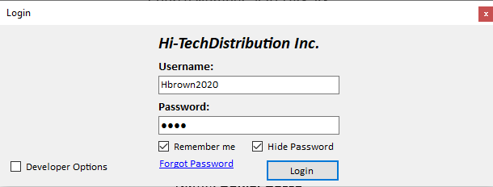

When you launch the application, you will be greeted with the form.

* Clicking on remember me will save your username and password for the next session
* Clicking on hide password will toggle between showing the password to the user or hiding it.
* Clicking on forgot password will send a message box to the user.
* Clicking login will log the user in provided they have provided the right username and password.
* Clicking developer options will show buttons which will allow you to log in as a specific user (This would be removed in full version but is left in to enable easy testing of the developers and the professor grading this.)

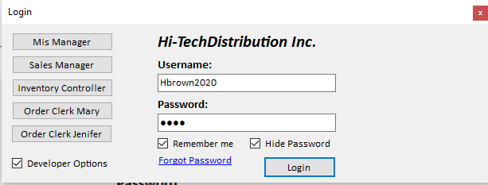

Once you login you will be greeteed with a tab relevent to your job title, for example the sales manager’s first tab will be customers. I chose to make this application using only 2 forms. One for the login portion and one for each of the employee’s using tab control. When you login you will only be able to see the tabs that are relevant to you, for example the MIS manager will only be able to access the employee and user tab and not for example the customer tab.

**Welcome tab:**

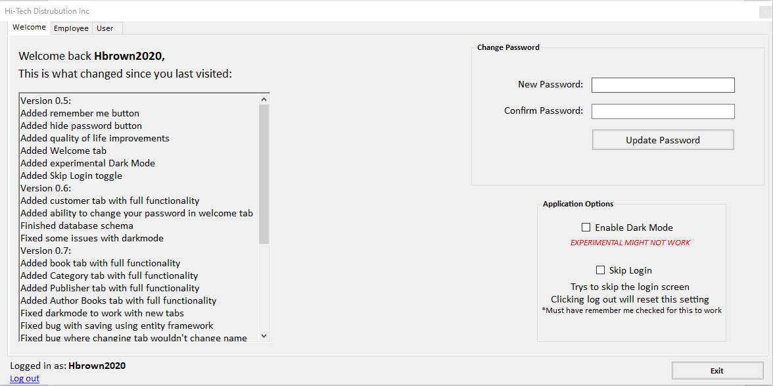

Every user will have access to the welcome tab in this tab you can:

* See a changelog that reads from a txt file placed in the application and can be easily updated.
* Change their password.
* Enable dark mode which will change the appearance of each one of the tabs.

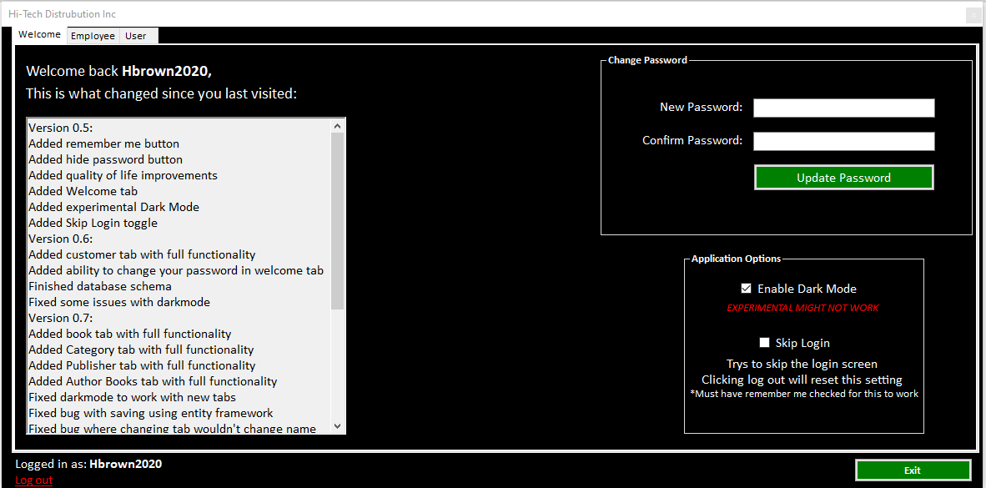

* Enable skip login button that works in conjunction with the remember me checkbox. If the remember me checkbox is checked then it will automatically log you in, skipping the login form. Credential validation is still taking place during this automatic login meaning that if someone changes the password of a user and they exit the application and try to login with automatic login it will not allow them.
* Able to log out of their account.
* Exit the application.

**Employee:**

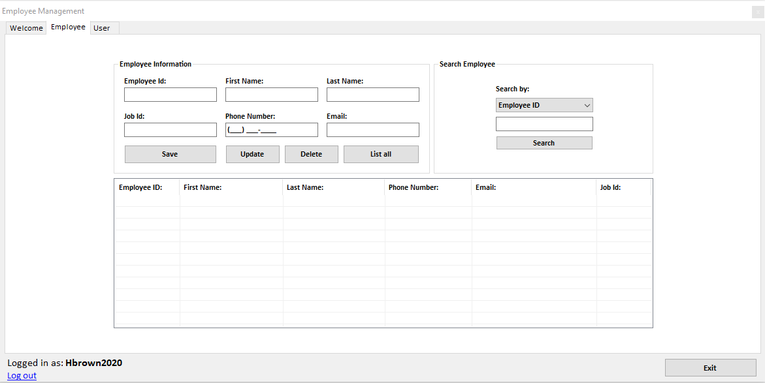

A User with the job title of MIS manager will be able to access the employee tab in this tab you can:

* Preform the CRUD operations.

**User:**

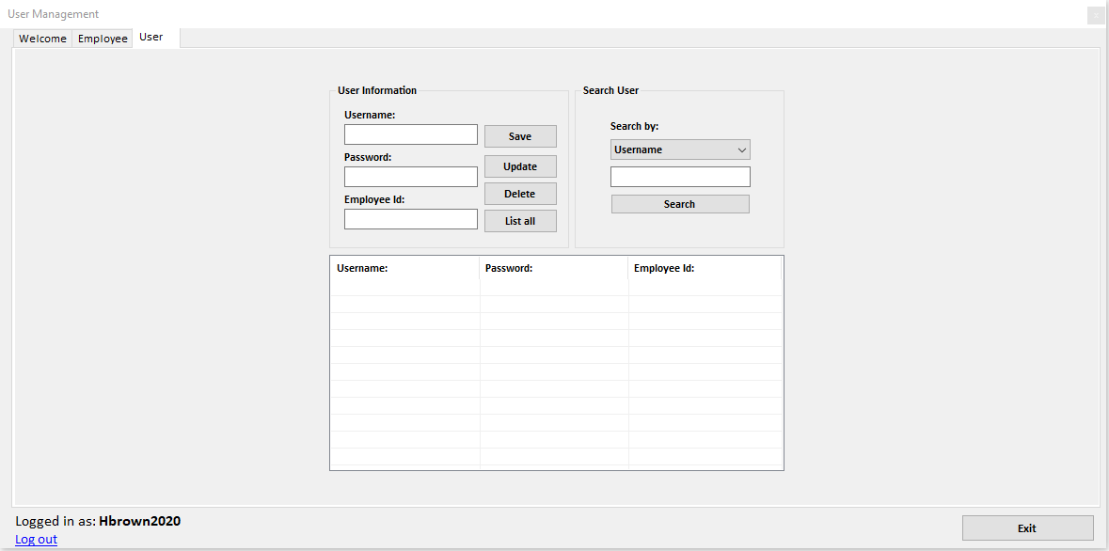

A User with the job title of MIS manager will be able to access the User tab in this tab you can:

* Preform the CRUD operations.

**Customer:**

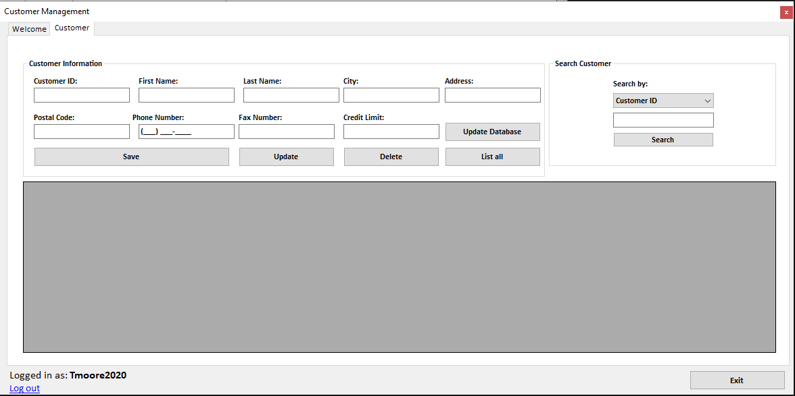

A User with the job title of Sales manager will be able to access the Customer tab in this tab you can:

* Preform the CRUD operations.

**Books:**

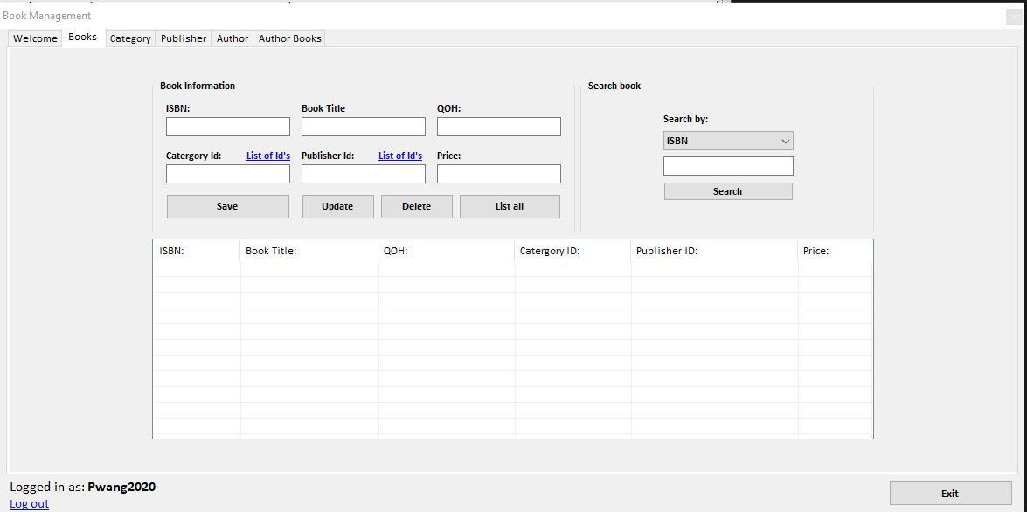

A User with the job title of Inventory Controller will be able to access the Book tab in this tab you can:

* Preform the CRUD operations.
* Clicking the list of category id’s will show a message box with a list of all categories for quick reference.
* Clicking the list of publishers id’s will show a message box with a list of all publishers for quick reference.

**Category:**

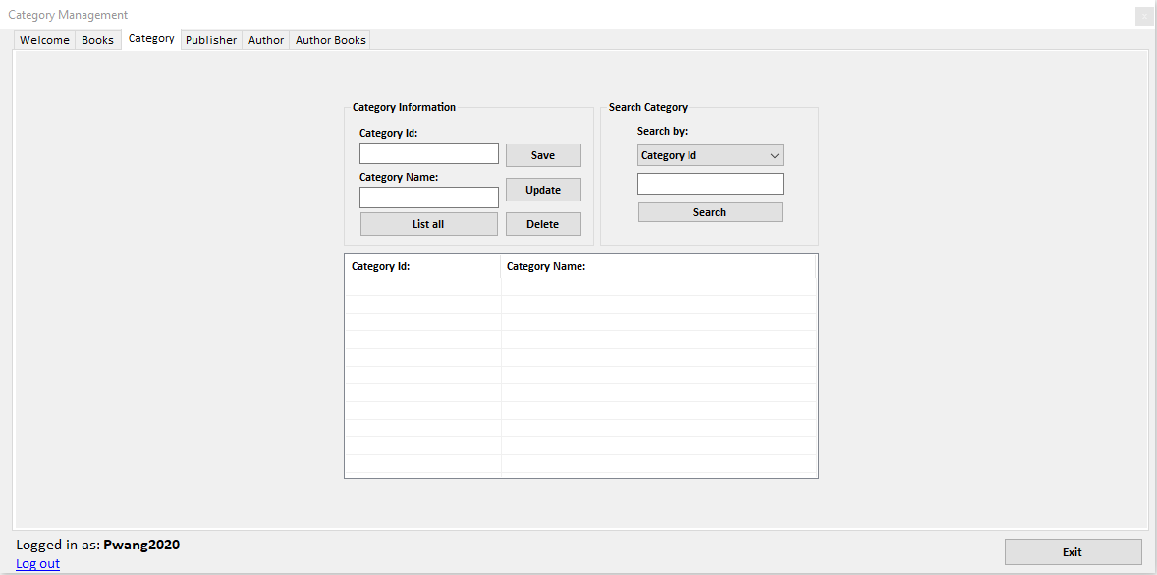

A User with the job title of Inventory Controller will be able to access the Category tab in this tab you can:

* Preform the CRUD operations.

**Publisher:**

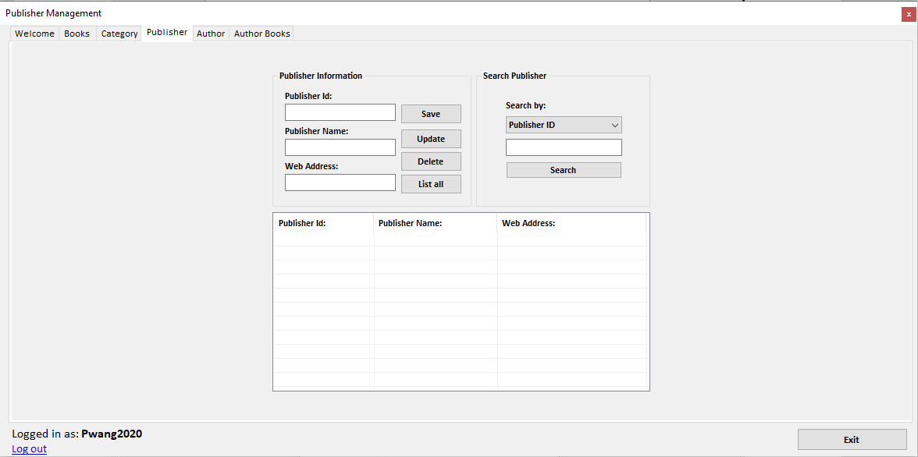

A User with the job title of Inventory Controller will be able to access the Publisher tab in this tab you can:

* Preform the CRUD operations.

**Author:**

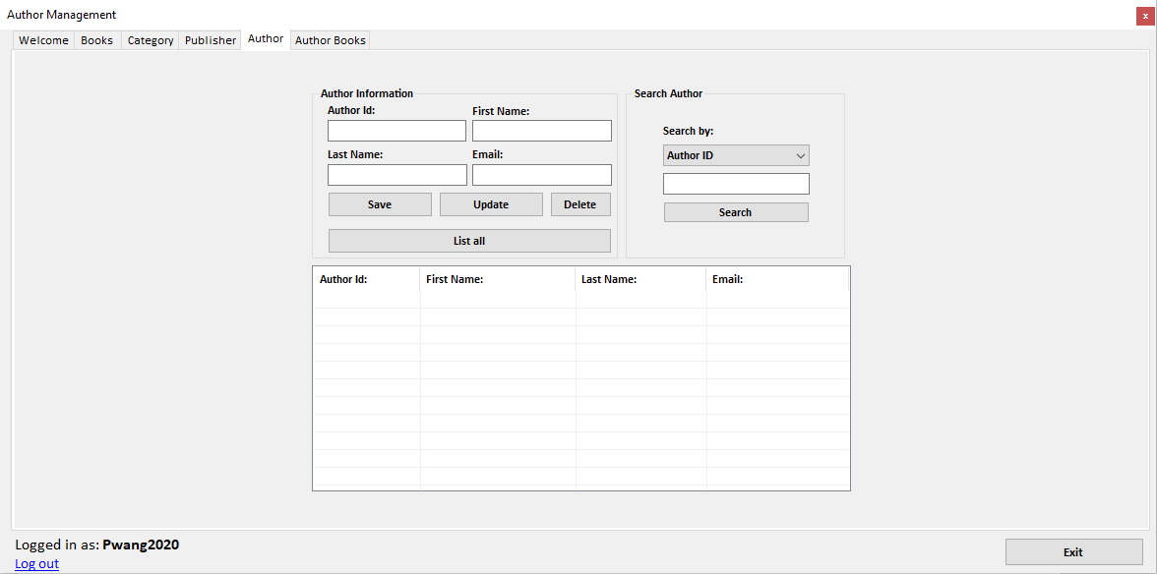

A User with the job title of Inventory Controller will be able to access the Author tab in this tab you can:

* Preform the CRUD operations.

**Author Books:**

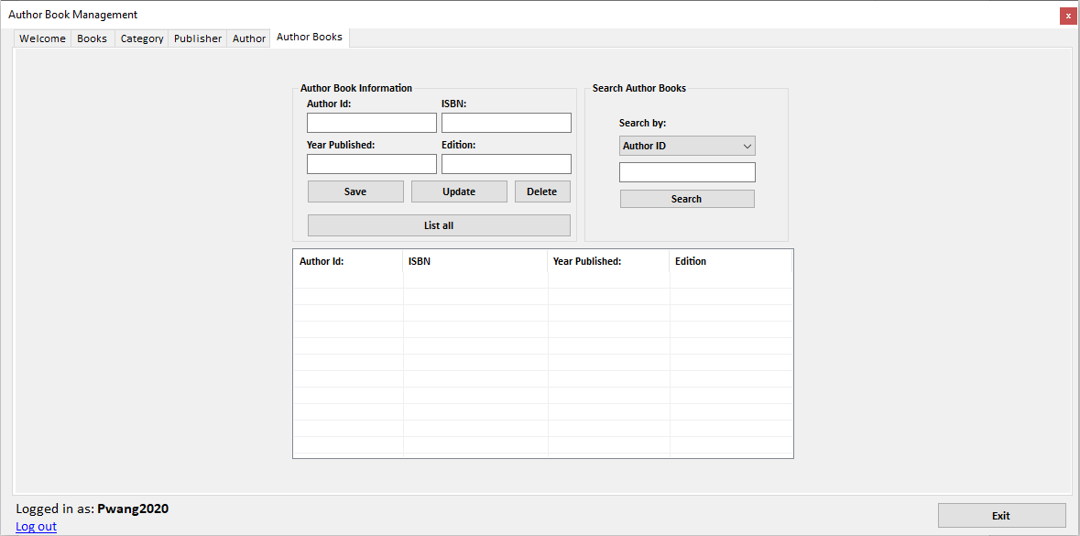

A User with the job title of Inventory Controller will be able to access the Author Books tab in this tab you can:

* Preform the CRUD operations.

**Orders:  
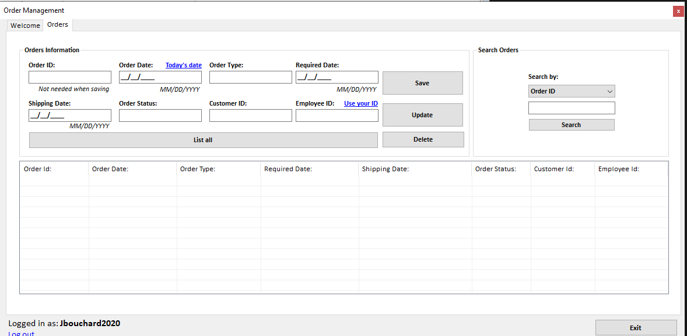**

A User with the job title of Order Clerk will be able to access the Orders tab in this tab you can:

* Preform the CRUD operations.
* Click today’s date to fill the order date as todays date using datetime.
* Click use your id to fill employee id with your employee id.

Project testing:

|  |  |  |  |  |  |  |  |  |  |
| --- | --- | --- | --- | --- | --- | --- | --- | --- | --- |
|  | User | Employee | Customer | Books | Category | Publisher | Author | Author Books | Orders |
| Add | OK | OK | OK | OK | OK | OK | OK | OK | OK |
| Update | OK | OK | OK | OK | OK | OK | OK | OK | OK |
| Delete | OK | OK | OK | OK | OK | OK | OK | OK | OK |
| Search | OK | OK | OK | OK | OK | OK | OK | OK | OK |
| List | OK | OK | OK | OK | OK | OK | OK | OK | OK |
| Validation | OK | OK | OK | OK | OK | OK | OK | OK | OK |

Testing with the application all the CRUD operations are working well. Validation is preformed on each textbox to ensure that we are placing the right information into the database.

***Username and password of the users:***

You can access all these options by clicking the **Developer options** checkbox and choosing a job.

MIS Manager: Username: Hbrown2020 Password: 2020

Sales Manager: Username: Tmoore2020 Password: 2020

Inventory Controller: Username: Pwang2020 Password: 2020

Order Clerk: Username: Mbrown2020 Password: 2020

Username: Jbouchard2020 Password: 2020

Conclusion:

This project really reinforced how we can implement different approaches to use a database in our code. Overall, the project was not very difficult but it was very long and tedious at points, but it really helps practice what we learned this semester.